MRI Performance Visualization

User Documentation

Team Tokyo

April 5th, 2019

# Team members

Esteban Cruz

Louis DiOrio

Evan Forbes

Armana Imsirevic

Nikola Lenert

Soowon Moon

Justin Namba

**Table of Contents**

**Team members** **1**

**Revision History** **4**

**Introduction** **4**

**Getting started** **4**

Load file(s) 4

Main Frame 5

Main Menu 5

Load File(s) 5

See Loaded File 6

Open Help Window 6

Open Settings Window 6

Close Application 6

Side Menu 6

Global Charts 7

Processes 7

Filter Data 7

Content 7

Global Charts 8

Processes 9

Open Charts Button 9

Query process Button 9

Filter Data 10

Submenu 10

Filter Section 11

Results Table 12

Help Frame 12

Settings Frame 12

Submenu 13

Side bar 14

Content 15

App Color 15

Font 15

Theme 16

# 

# 

# **Revision History**

|  |  |  |  |
| --- | --- | --- | --- |
| **Version** | **Date** | **Name** | **Description** |
|  |  |  |  |
|  |  |  |  |

# 

# **Introduction**

# **Getting started**

## **Load file(s)**

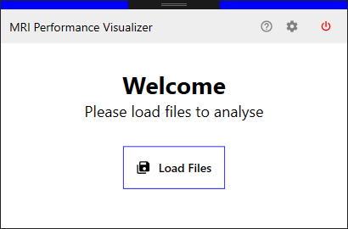

**Figure 1. Loading Files**

On figure one … Here you can load your UTR file … bla bla

## **Main Frame**

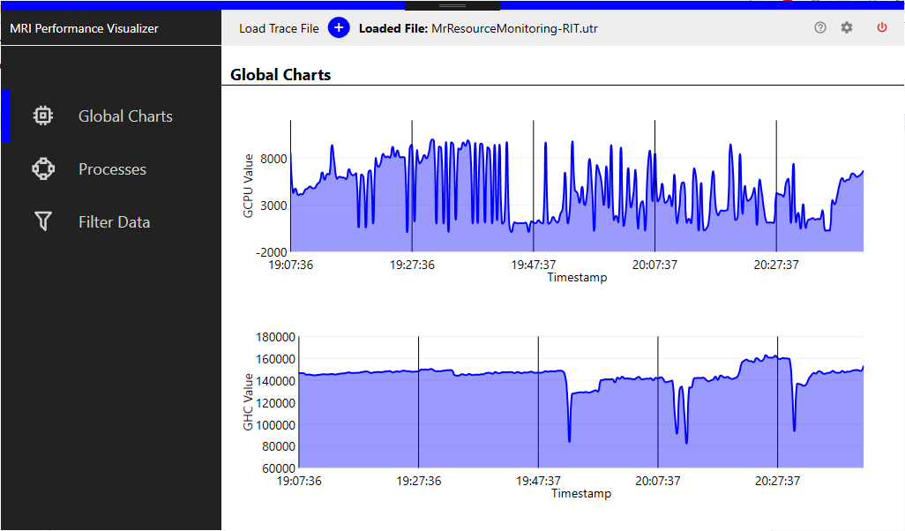

Figure 2. Main Frame

Main frame consists of 3 main parts:

1. Main Menu
2. Side Menu
3. Content

### Main Menu



Figure 3. Main Menu

In general about menu.. Bla bla Here are few basic options of the menu:

#### Load File(s)



#### See Loaded File



#### Open Help Window



#### Open Settings Window



#### Close Application

### 

### Side Menu

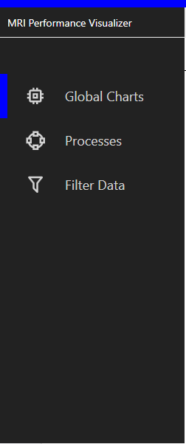

Figure # Side Menu

#### Global Charts



#### Processes



#### Filter Data



### Content

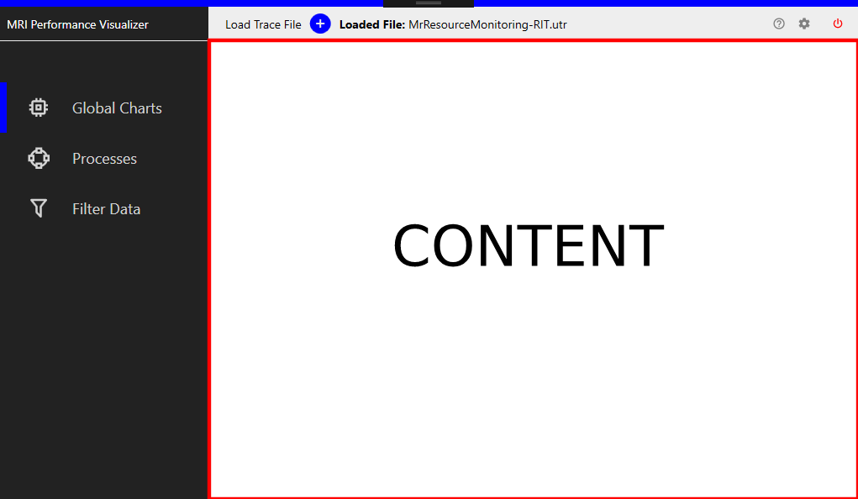

Figure # Content

#### Global Charts

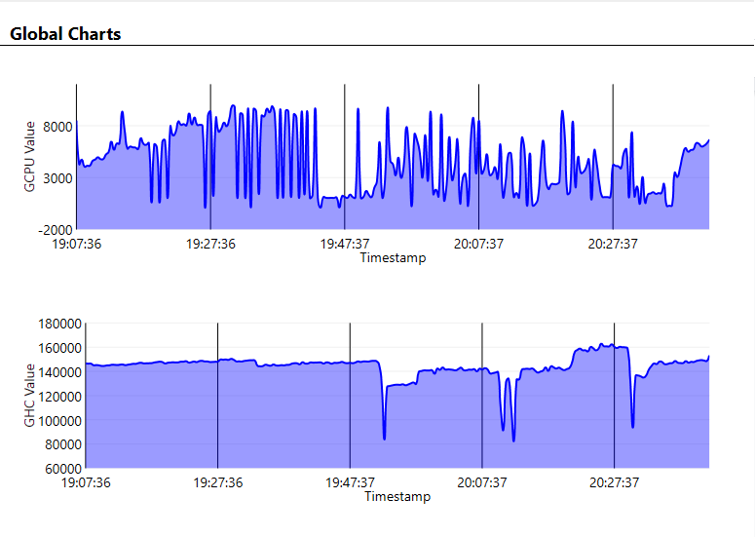

#### Processes

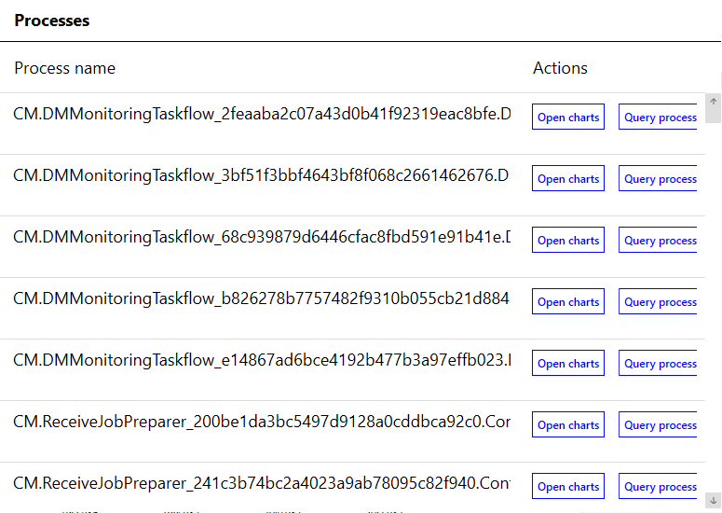

##### Open Charts Button



##### Query process Button



#### Filter Data

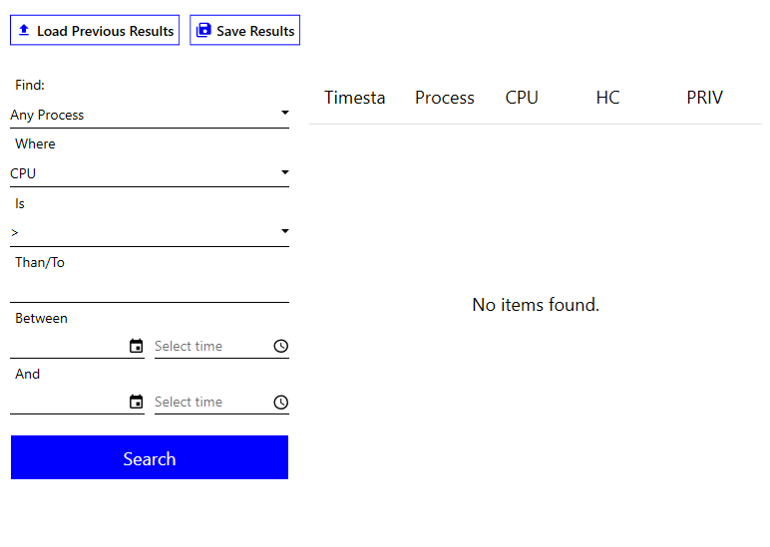

Consists of 3 parts:

##### Submenu



##### Filter Section

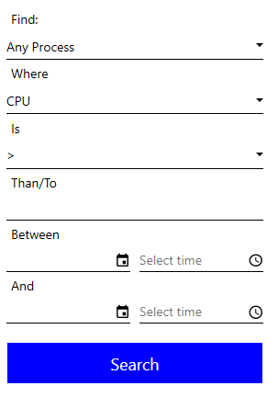

##### Results Table

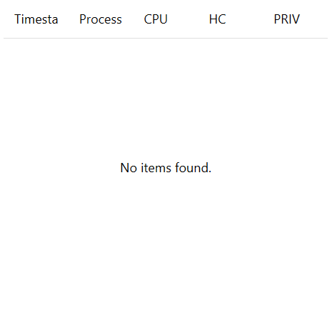

## **Help Frame**

## **Settings Frame**

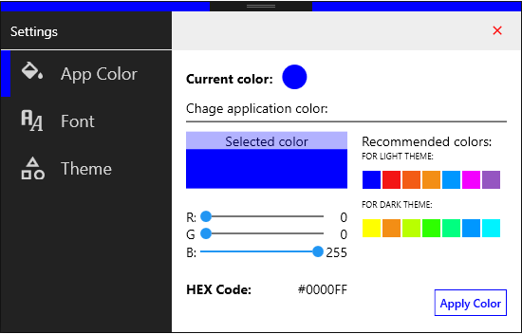

Figure # Settings Frame

Consists of three parts:

### Submenu



### Side bar

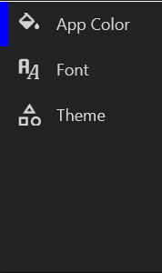

### Content

### 

#### App Color

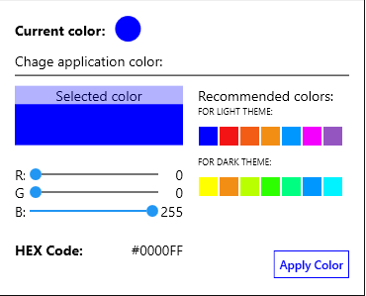

#### Font

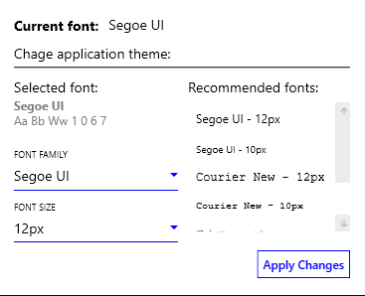

#### Theme

